
Spectroscopy of molecules

Objective: Infrared (IR) spectroscopy examines how infrared radiation interacts with molecules through absorption, emission, or reflection, providing valuable insights into molecular structure. It analyzes transitions between electronic, vibrational and rotational energy levels, which are determined by the molecular potential energy surfaces, atomic masses, and vibronic couplings.
Due to its precision and reliability, IR spectroscopy is widely used in research and industry for quality control, real-time monitoring, environmental analysis, or material characterization. Since each molecule has a unique infrared spectrum - like to a fingerprint - this technique enables precise identification and analysis of substances.
The objective of this module is to simulate the IR spectrum of a diatomic molecule, allowing students to deepen their understanding of fundamental spectroscopic principles, molecular structure, and dynamics.

Activity with the interface.
https://qtechedu.centralesupelec.fr/EN/ex2.html
This module explores the concepts of rotational-vibrational spectroscopy using diatomic molecules like carbon monoxide (CO). Diatomic molecules provide a simpler, more interpretable model for understanding fundamental principles of rotational-vibrational spectroscopy.
To observe a rotational-vibrational spectrum, a molecule must meet the following conditions:
- it must be infrared active (dipole moment change);
- it must exist in the gas phase;
- its rotational energy levels must be populated at a given (T = 300K) temperature;
- the selection rules for rotational-vibrational transitions must be satisfied.

1. Introduction
- What is molecular spectroscopy, and what problems does it address?
- What molecular parameters can be obtained from rotational and vibrational spectroscopy?
- Analyze the potential energy diagram for carbon monoxide. Indicate the molecular energy levels, the types of possible transitions, and the corresponding spectral ranges for each.
- The CO molecule can be approximated as a rigid rotor with a fixed bond length at equilibrium. Draw a schematic representation of the CO molecule based on this model. Label the key features, including the bond length, the atoms involved, and indicate the direction of vibration and the axis of rotation. What mass is used for the molecule in the calculation?
- What units are used in calculation* , demonstrating experimental results.
2. The tab Potential energy and wave function is used for visualization the potential energy profile, vibration levels and wave function for CO molecule.
The ‘’Run calculation” and “Reset to default” buttons are used to run calculations with new parameters or to restore the default values, respectively.
The “Update” button allows you to modify the output parameters. If you need to save the result, click the “Save current data” button.
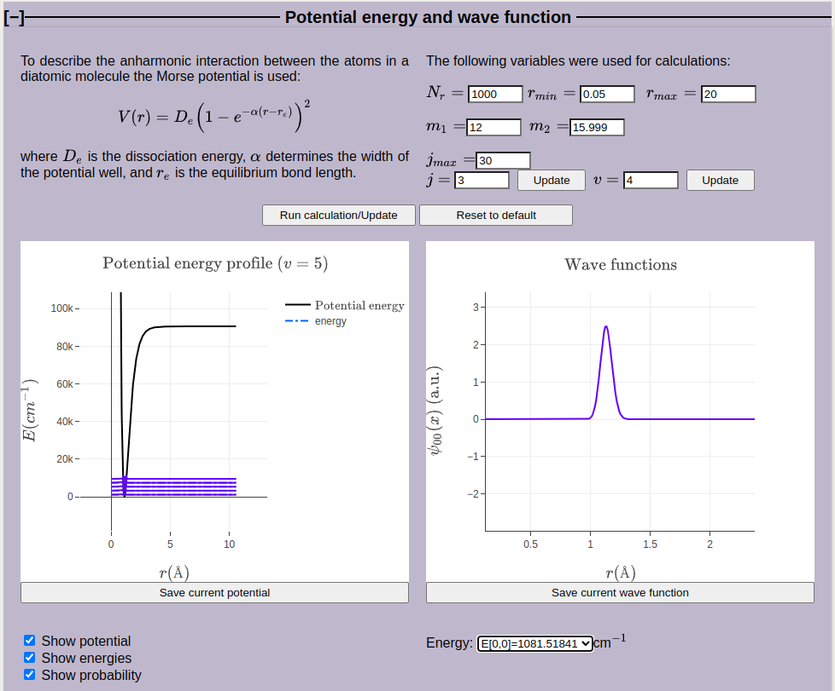
1. The following parameters can be adjusted:

- Number of grid points: N_{r} = 1000;
- Minimal and maximal distance between atoms: r_{min} = 0.05 a.u. , r_{max} = 20 a.u.;
- Mass of the atoms: m₁ = 12 u, m₂ = 15,999 u (in atomic mass units !!!);
- Maximum number of rotational levels (j) considered in the calculation: j_{max} = 30;
- The number of rotational levels (for j =0 to 3) and vibration levels (v =4) to be displayed: these parameters can be adjusted within the specified range without restarting the calculation.
2. Perform calculations for different numbers of rotational levels, within the range of 10 to 20.
3. In the Observables tab, the physical quantities that can be obtained from experiments are calculated.
Write down the formulas for each value, specifying the variables used and what each value characterizes. In particular, indicate the values obtained from the figures in arbitrary units* and SI units.

4. Selection rules

- What is the meaning of the selection rules in molecular spectroscopy?
- Examine the figures (the values of the transition dipole moment for different values of v, v’ and j, j’) in the 'Selection Rules' tab. Where are these values derived from?
- Explain what you observe in these figures in relation to the selection rules for rotational and vibrational transitions. Formulate the rules.
- How do these rules determine the allowed transitions for a diatomic molecule like CO?
- Provide examples of allowed and forbidden transitions based on these rules.

5. Application: Rotational-vibrational spectroscopy. The intensity of a rotational-vibrational transition in the molecule CO presented in this section.
- Explain the appearance of the P and R branches in the spectrum based on selection rules.
- Discuss the intensity pattern of the peaks in the spectrum (increase followed by a decrease in intensity with frequency).
- How does the spectrum change with temperature? What happens to the intensities and positions of the spectral lines as the temperature increases. Explain this dependence and confirm with calculations (use the platform).
- Which rotational transition will produce the most intense spectral line in the rotational spectrum at 300K?

To compare the obtained calculated spectrum with experimental one (select the appropriate option below the figures). Verify whether the spectra agree for different j = 10, 20, 30. Make the conclusions.

Problem:
Analyze the rotational-vibrational absorption spectrum from the ground vibrational state to the first excited state of CO (or HCl).
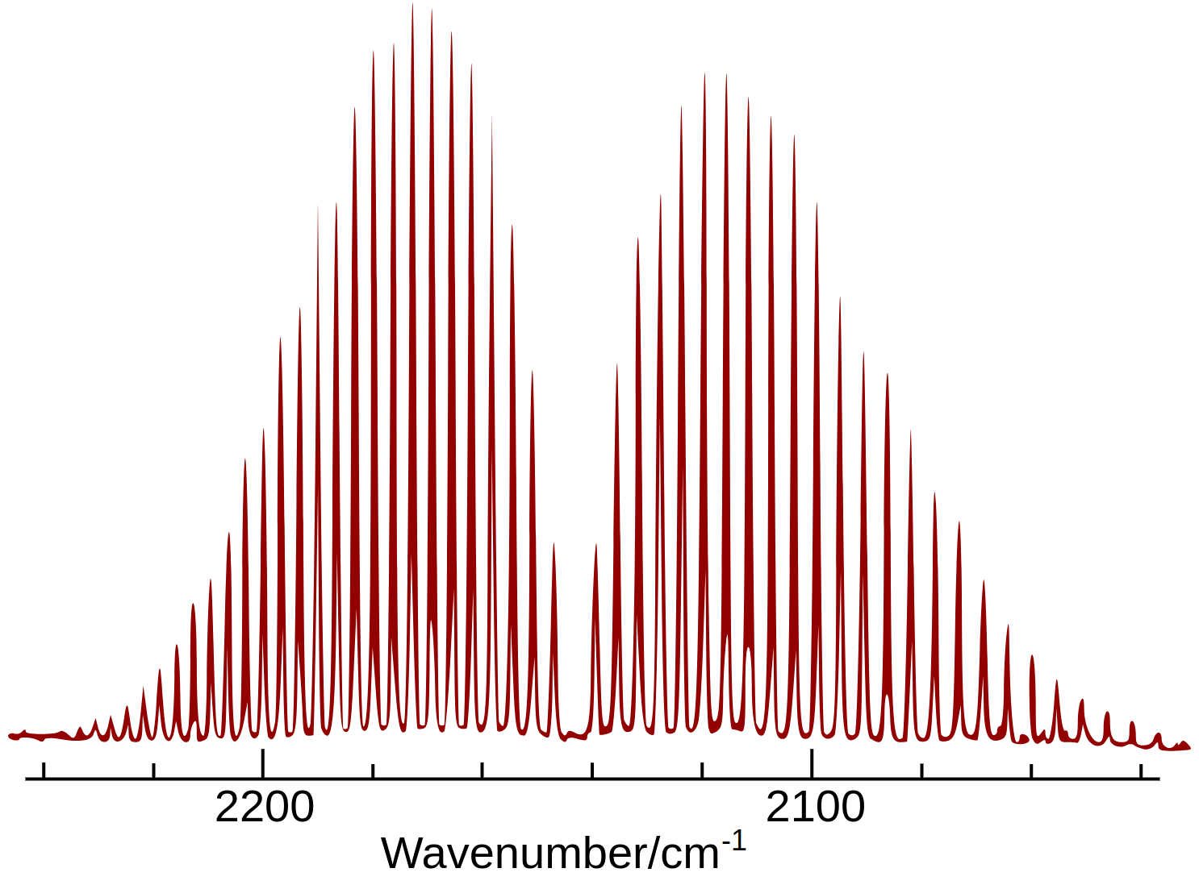 | 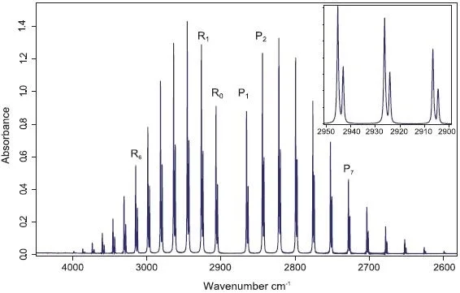
Experimental rotational-vibrational absorption spectrum of CO (carbon monoxide) obtained by Fourier Transform Infrared (FTIR) spectroscopy method. https://commons.wikimedia.org/wiki/File:Carbon_monoxide_rotational-vibrational_spectrum.png | FT-IR spectrum of HCl (hydrogen chloride) in the gas phase. Insert: The ro-vibrational lines are split due to the chlorine 35 and chlorine 37 natural isotopic ratio. https://www.azom.com/article.aspx?ArticleID=15226

- Prove that the distance between two nearest peaks is equal to 2B.
- Determine the moment of inertia (I), equilibrium bond length (r_{e}) and the dissociation energy D of molecule using experimental spectra.
- Identify the initial and final rotational quantum numbers for the transition corresponding to the absorption peak at 2154.55 cm⁻¹. Draw an arrow representing this transition on a diagram (similar to the one in the “Selection Rules” section).
- Determine the average rotational constant (B) of the molecule.
- Calculate the bond length using obtained value for B above.
- Estimate the wave number of the vibrational transition for CO (HCl).
- Calculate the wave number (in cm⁻¹) of the j = 1 ← 0 transition in the pure rotational spectrum. Estimate the energy required for this transition.
- Determine the fundamental vibrational frequency from the spectrum. Using this frequency, calculate the force constant (spring constant) of the molecule.
- Demonstrate how the rotational-vibrational spectrum can be used to measure the temperature of the sample.

Solution method:

* Atomic units https://en.wikipedia.org/wiki/Hartree_atomic_units are used:

the unit of charge is e = 1 (1.602176634×10⁻¹⁹C);
the unit of mass m_{e} = 1 is defined as the mass of the electron (9.1093837139(28)×10⁻³¹ kg);
the unit of action = 1 - reduced Planck constant (1.054571817...×10⁻³⁴ J⋅s);
the unit of length a₀ = 1 - Bohr radius (= 0.529×10⁻¹⁰m);
the unit of energy E_{H} = 1 - Hartree energy (= 4.359×10⁻¹⁸ J = 27.211 eV).

The masses in the boxes below are given in daltons (Da) or unified atomic mass units (u). The unified atomic mass unit should not be confused with atomic unit of mass m_{e}. 1u= 1822.88848 m_{e}.

